Brand Guidelines

Goal:
Minimalistic, Clean, Cutting Edge, Approachable

Colors:
#FFFFFF Pure White
#E64891 Pink
#389BCE Light Blue 2
#3DAEE3 Light Blue
#2067b2 Blue
#394a90 Dark Blue

To maintain the minimalist, white will be the dominant color for all designs

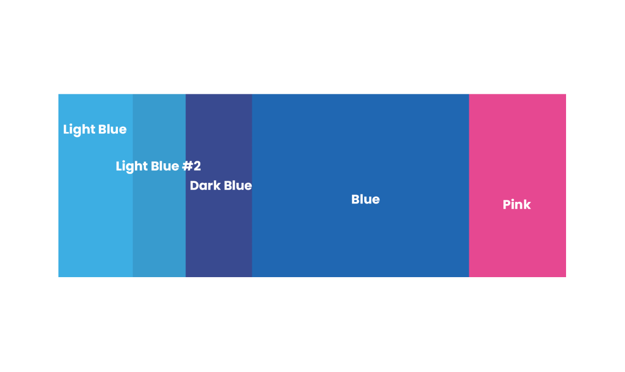

Fill Color:
Fills can be light blue #2 or blue. Gradient fills can be from Light Blue #2 to Dark Blue or from Light Blue to Pink

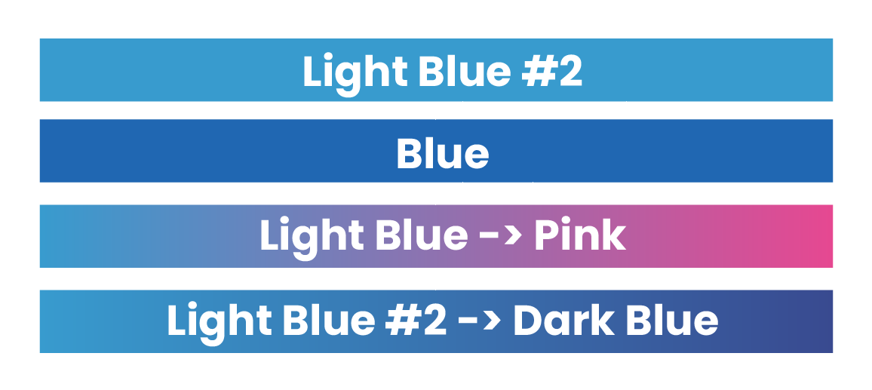

Approved Logos

Only Approved logos can be used. Do not add drop shadow to the logo. Logos can additionally be white or just the Logogram “B”






Font:
The primary font used is Poppins. Any the style of the poppins family can be used. But most current stylisations range from regular to bold font styles. Text may be colored with brand colors or any achromatic grey or black. But Pink may only be used sparingly and to draw attention.
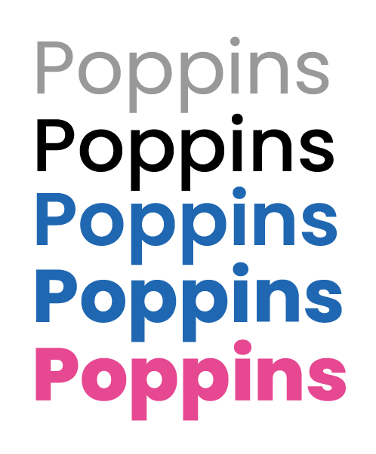

Other Style Notes:
Rounded corners and drop shadows are featured frequently and should be used subtly but frequently.
Drop shadow can be either black/gray or dark purple as long as its used consistently.


